Silver Awards

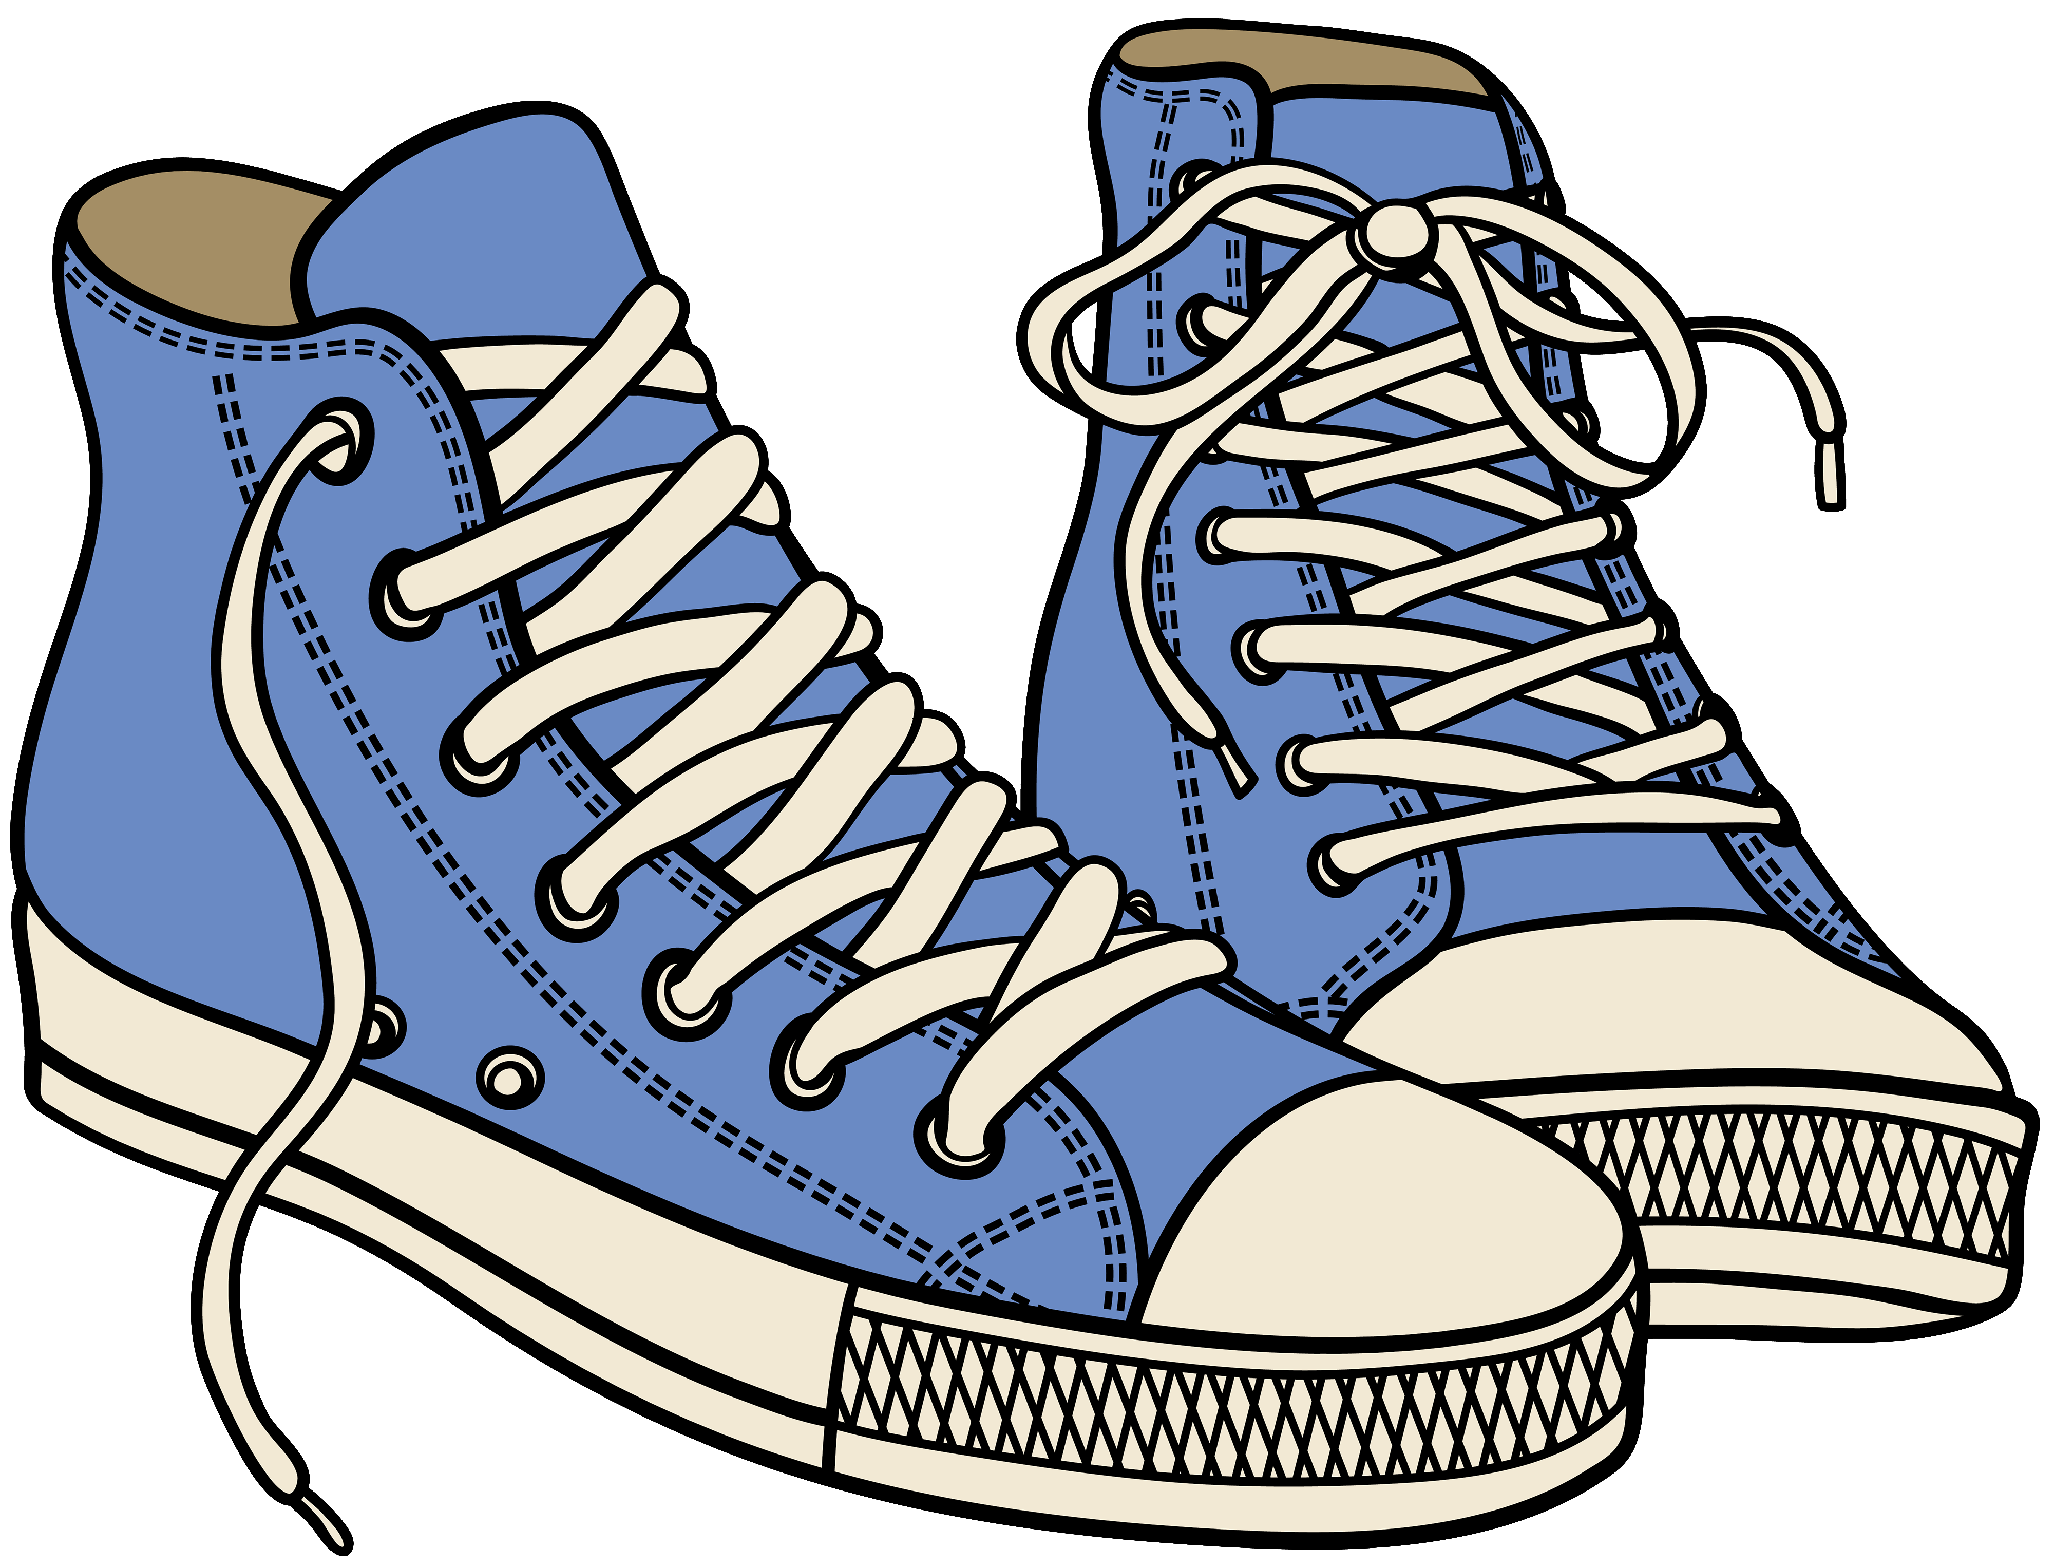

**Silver Sneaker**- Award given to classrooms that follow the 3Bs in the hallway. Classrooms that are given the award have a parade throughout the school.



**Silver Basketball**- Award given to classrooms that follow the 3Bs on the playground. Classrooms that are given the award have extra time on the playground.

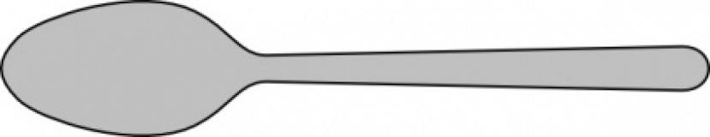

**Silver Spoon**- Award given to classrooms that follow the 3Bs in the cafeteria. Classrooms that are given the award are given a special treat.